Docker Desktop Setup Guide (Windows)

1. Download Docker Desktop
- Go to the official site:
https://www.docker.com/products/docker-desktop
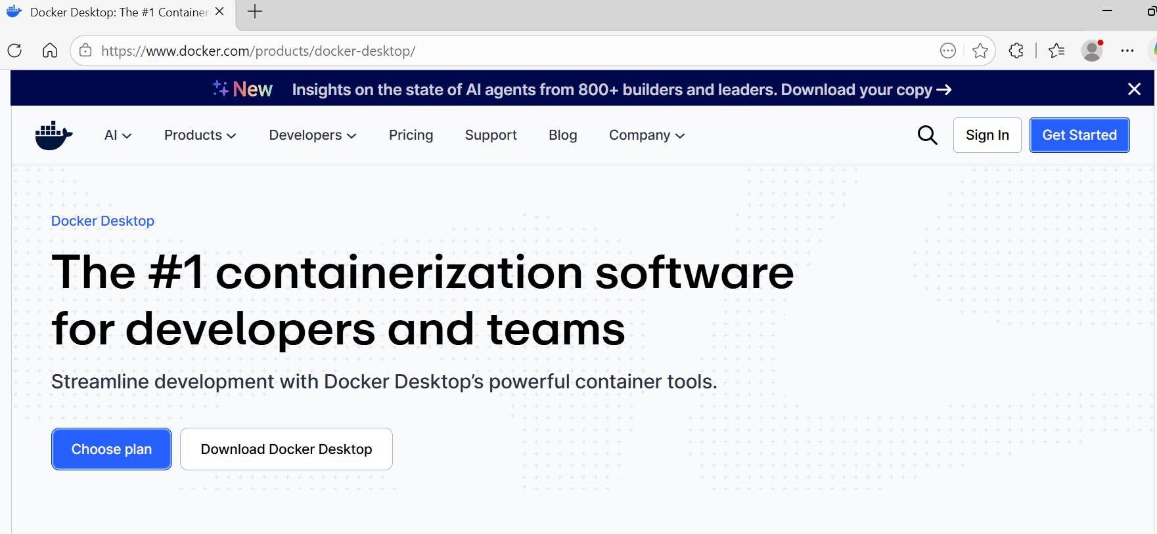
- Click Download for Windows – AMD64 or ARM64 as per needed.
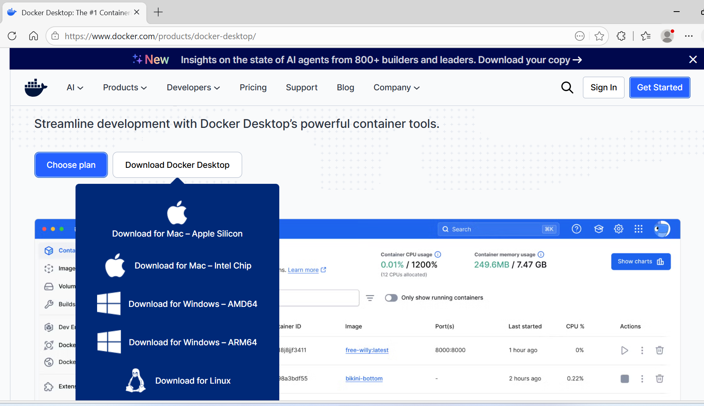

2. System Requirements
Before installing, make sure:
- Windows 10/11 (64-bit)
- Virtualization enabled in BIOS
- WSL 2 (recommended)

3. Objective
The objective of this guide is to give a simple step by step walkthrough on how to setup Docker Desktop on your PC/ Laptop.

4. Enable Virtualization
To check:
- Open Task Manager → Performance tab
- Look for Virtualization: Enabled
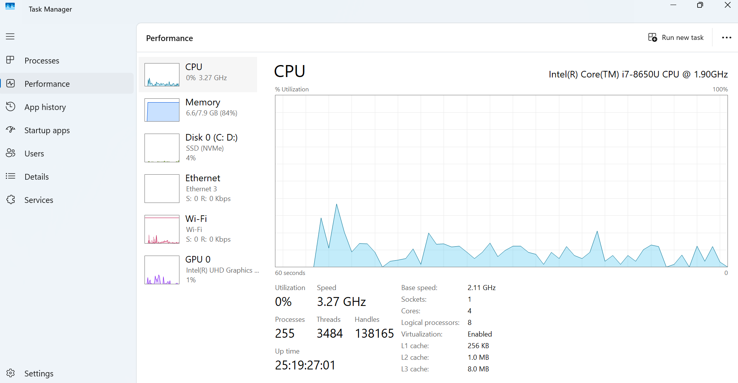
If disabled:
- Restart PC → Enter BIOS (F2 / DEL / ESC)
- Enable:
  - Intel VT-x or
  - AMD-V

5. Install WSL 2 (IMPORTANT)
Open PowerShell as Administrator and run:
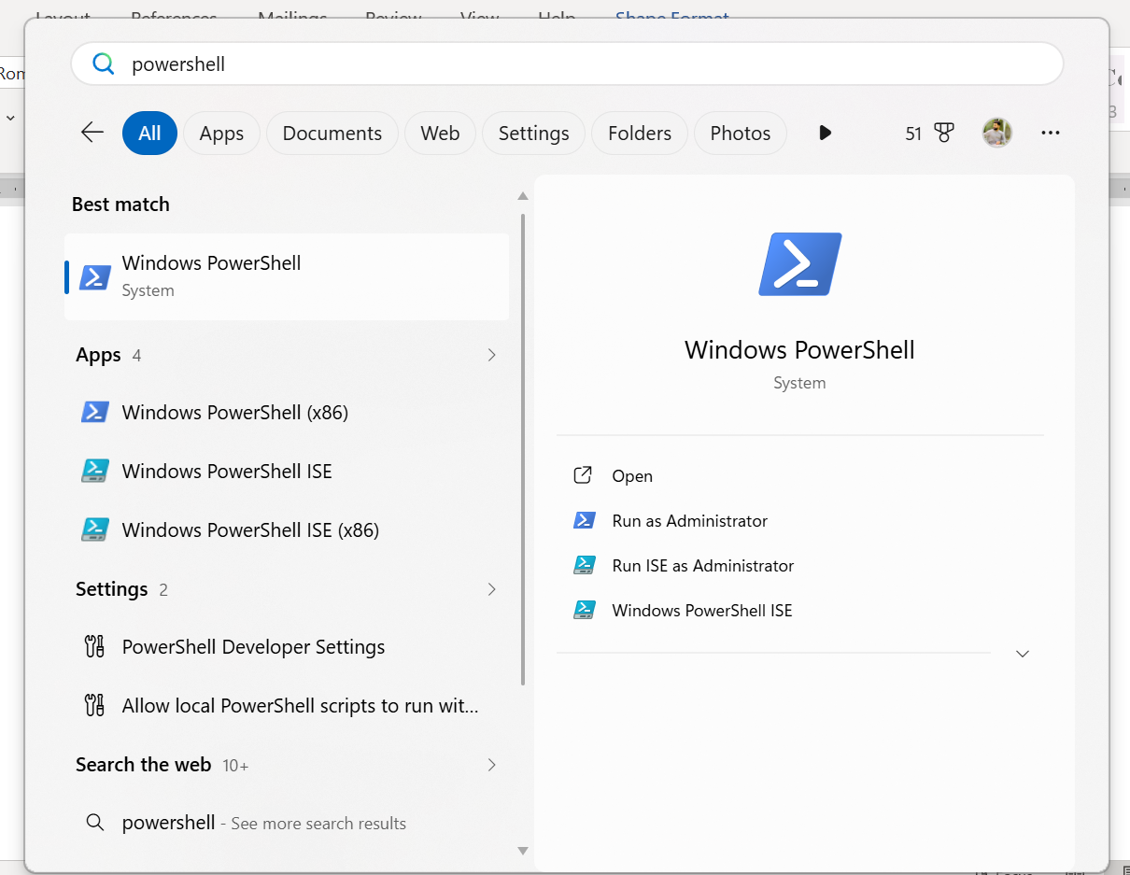

wsl –install
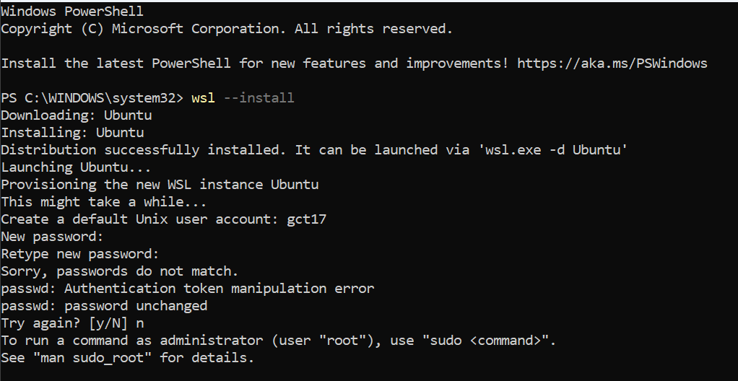
Then restart your system.
To confirm, you can use these 2 commands:
wsl --version
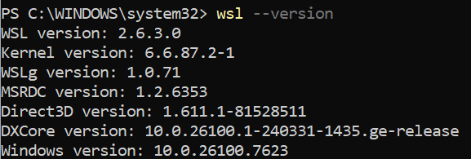
wsl --list –verbose

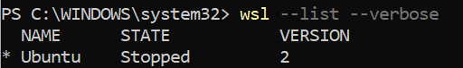
Make sure version is 2.

6. Install Docker Desktop
- Run the downloaded .exe file
- During installation:
  - ✅ Select Use WSL 2 instead of Hyper-V
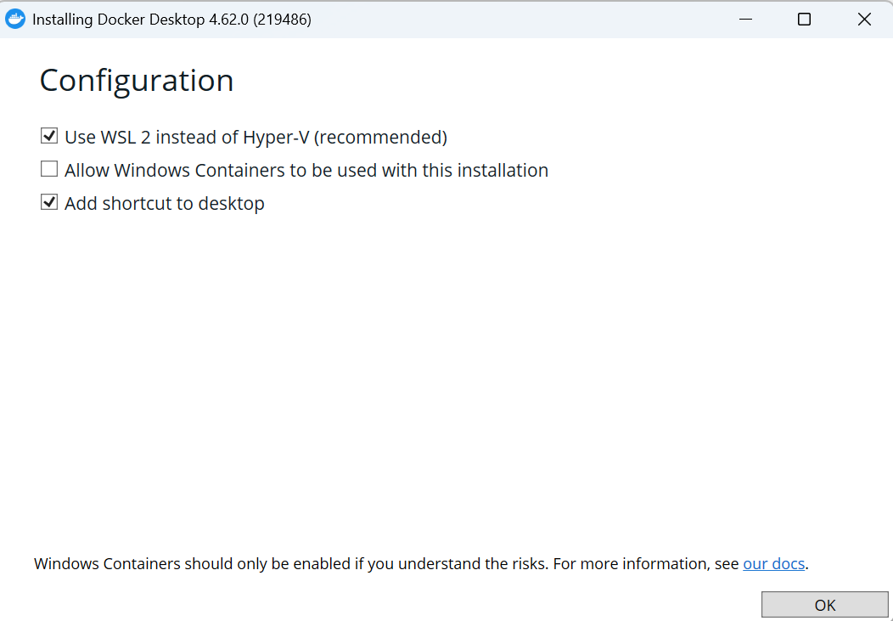

- Click Install
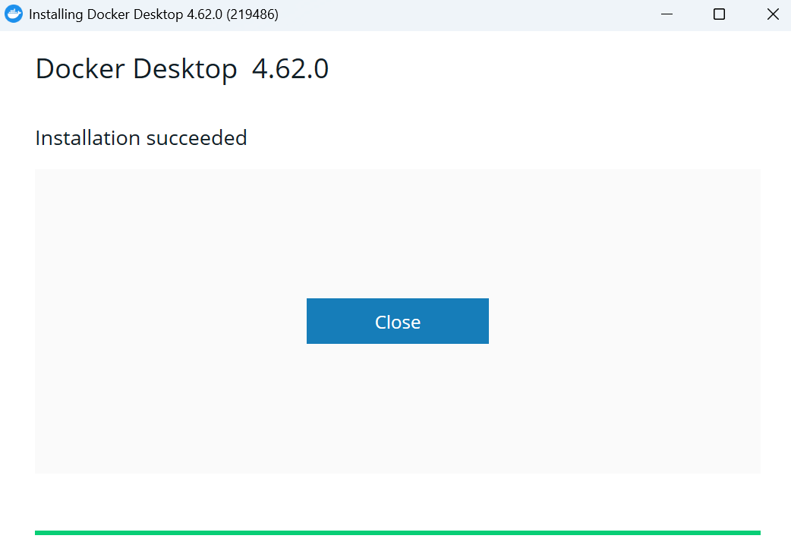
After installation → Restart PC

7. Launch Docker Desktop
- Open Docker Desktop from Start Menu

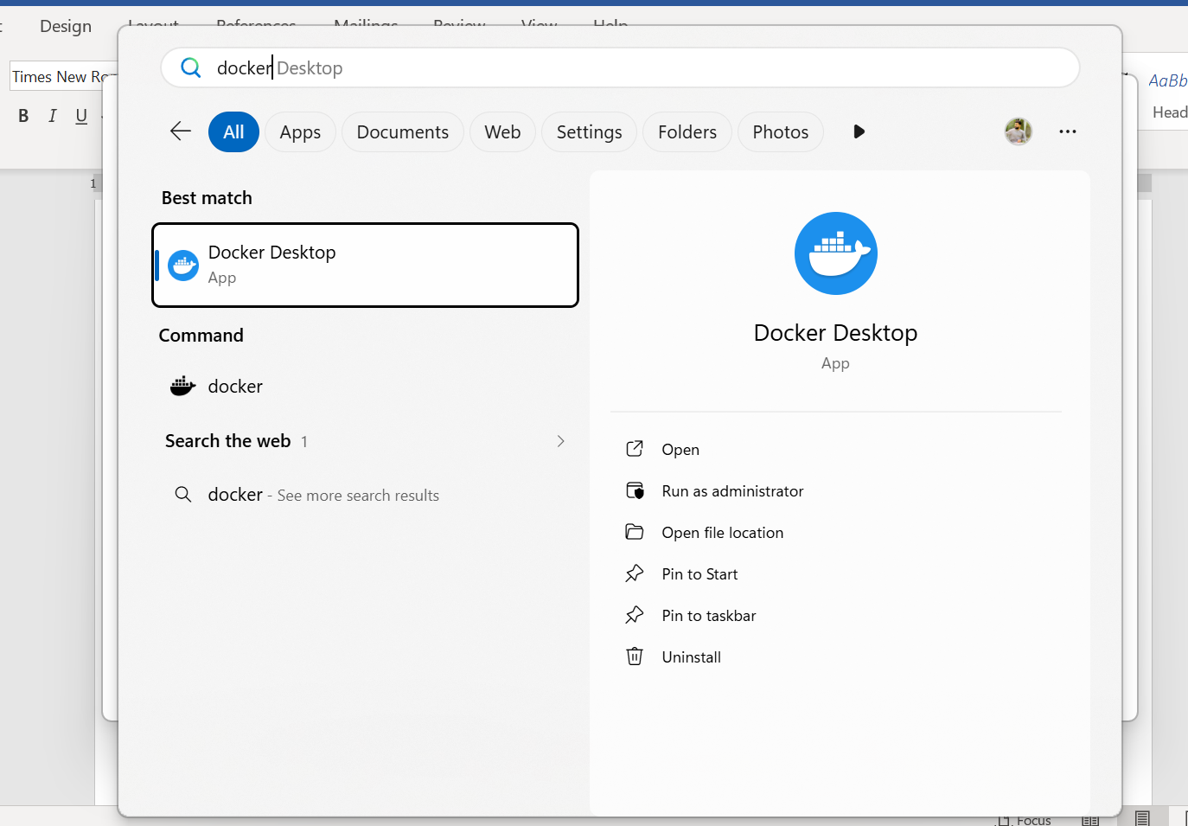
- Wait until it says:
"Engine running"
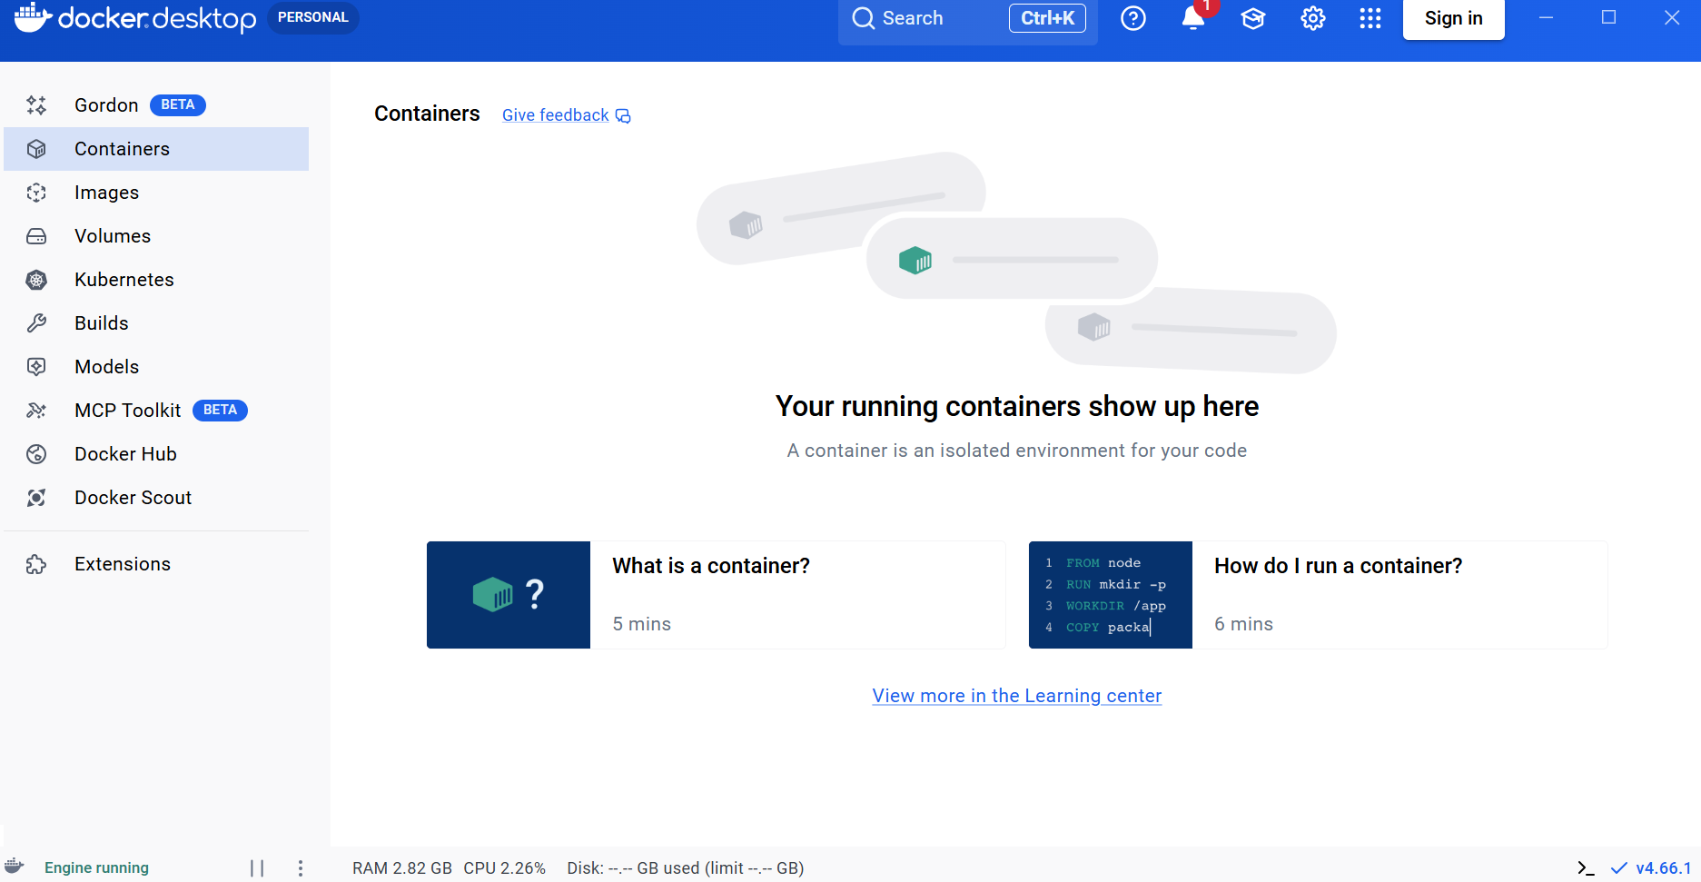

8. Sign In (Optional but recommended)
Create/login account on Docker Hub or you can skip.
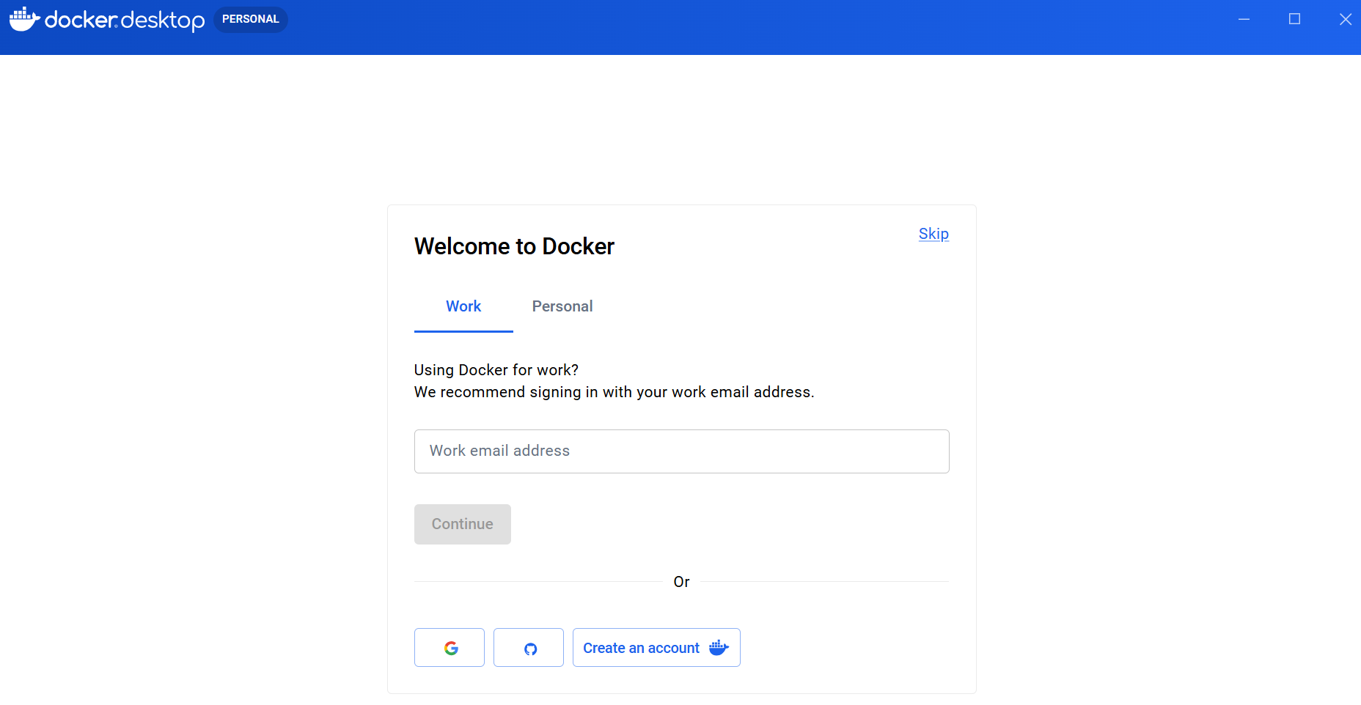
Update Docker If need.
Click Download Update.
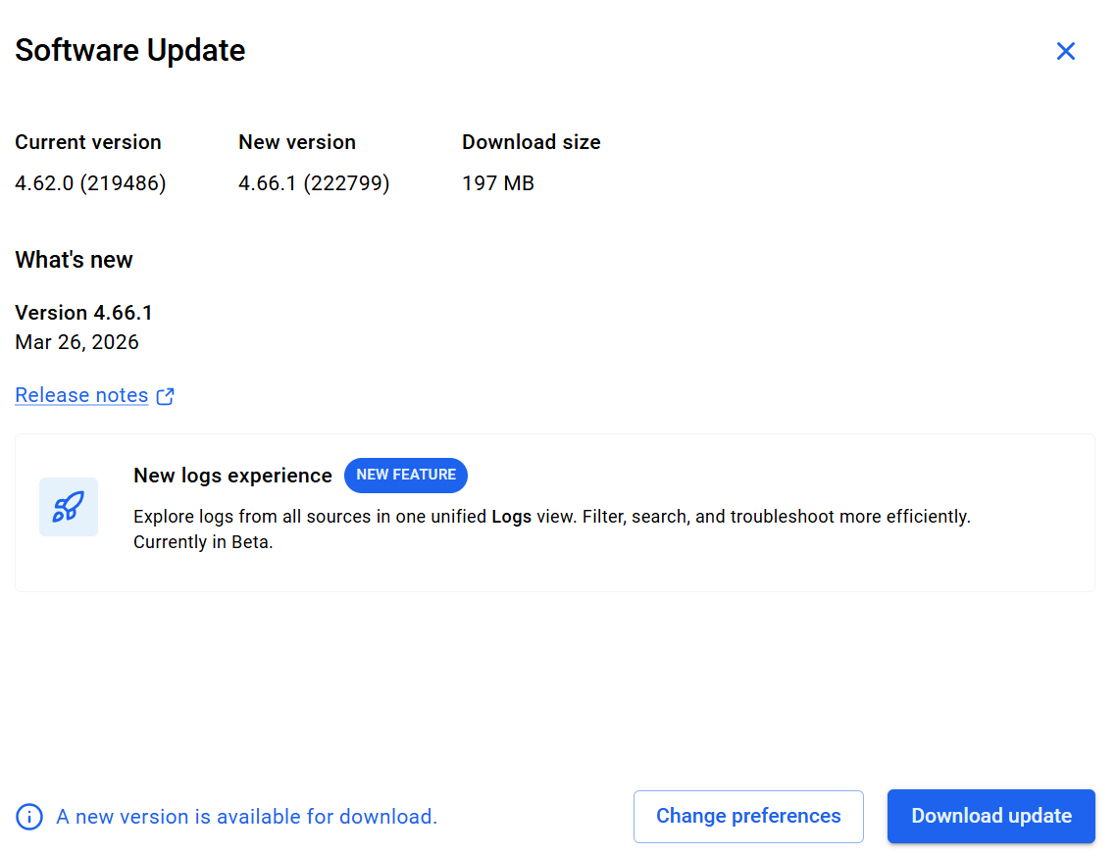

9. Verify Installation
Open Command Prompt / PowerShell:
docker –-version
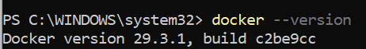
Then test with:
docker run hello-world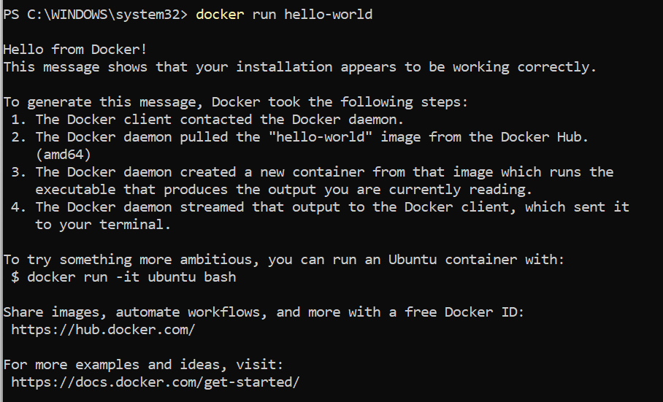
If successful, you’ll see a confirmation message.

10. Run Your First Container
Try running an Nginx server:
docker run -d -p 8080:80 nginx
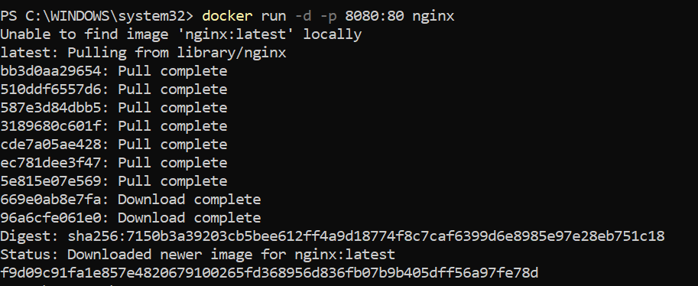
Then open browser:
http://localhost:8080
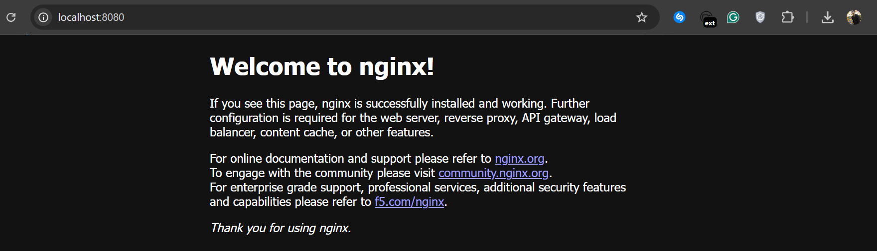

11. Useful Commands
Command | Description
docker ps | Show running containers
docker ps -a | Show all containers
docker images | List images
docker stop <id> | Stop container
docker rm <id> | Remove container

Docker ps
Docker ps -a
Docker images
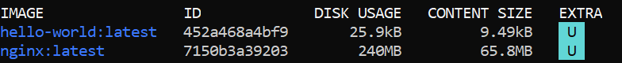
Docker stop <id>
Docker rm <id>

12. Common Issues & Fixes

WSL not working
wsl --set-default-version 2

Docker not starting
- Restart Docker Desktop
- Check WSL is running:
wsl

Port already in use
Change port:
docker run -d -p 9090:80 nginx

